Spreadsheet Gradebook Tutorial

Setting up the spreadsheet
Open a new Excel workbook page.
Make sure you have the following toolbars: standard, formatting, drawing
In Cell A1 type Last Name
In Cell B1 type First Name
Follow the diagram below to fill in the headings for Cells C1-M1.

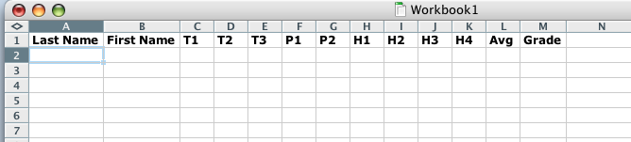

Enter the students’ last names in Column A and first names in Column B.
Enter the students’ grades in Columns C-K.

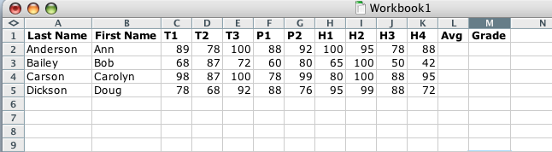

Create a legend
Draw a textbox on your spreadsheet to create a legend
Include detailed information about each of the assignments in the grade book.
Resize the legend to fit your text, and add color to the legend
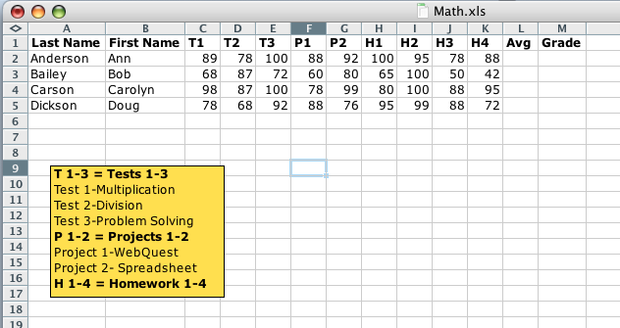
Legend

Class Averages
Now you are going to determine the class average for each assignment. This is important for you to know because this tells you the class’s overall mastery of the topic. Think of these as your grades that reflect how well your students have learned the material being taught.
In Cells 7A and 7B type the words Class Average
Click in Cell C7. In the formula bar at the top of the worksheet, type =average( Then click on Cell C2 and drag down to Cell C5. Click return. The spreadsheet will average the grades in those cells and the average score will appear in Cell C7.
Again click on cell C7 and copy the cell. Then click on Cell D7 and drag to Cell K7 and paste.

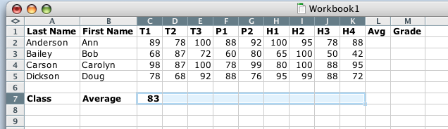

The average grade for each assignment will now appear in the appropriate cells.
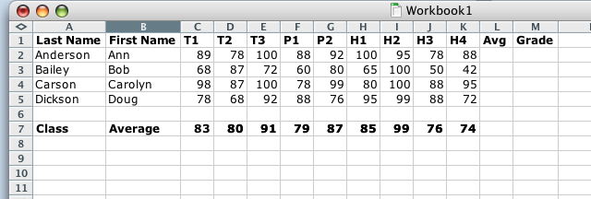

Next, we are going to determine the students’ average grades. The first thing we will do is determine a grading scale. For this spreadsheet, the tests are worth 40% of the total grade, the projects are worth 50% of the total grade, and the homework is worth 10% of the total grade.
The spreadsheet will create a formula to help us do this. The formula looks like this:

=(((C2+D2+E2)/3)*0.4)+(((F2+G2)/2)*0.5)+(((H2+I2+J2+K2)/4)*0.1)

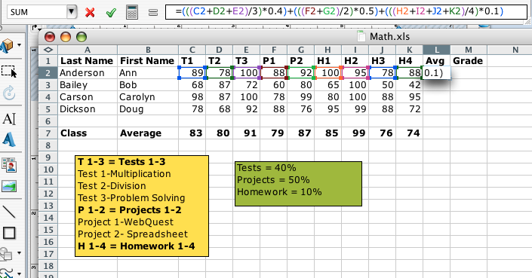
Grading
Scale
You can just copy and paste the Legend and change the text and color to create your grading scale!

Equation for determining grades (Function) - The equation above applies the stated grade policy. If you can state your grade policy as an equation, you can write an Excel function to do the calculation. The function above does the following
- Test grades
  - Add the three grades (C2+D2+E2)
  - Divide by the number of grades (average)
  - Multiply by 0.4 (40 %)
- Project grades
  - Add the two grades (F2+G2)
  - Divide by the number of grades (average)
  - Multiply by 0.5 (50 %)
- Homework grades
  - Add the four grades (H2+I2+J2+K2)
  - Divide by the number of grades (average)
  - Multiply by 0.1 (10 %)

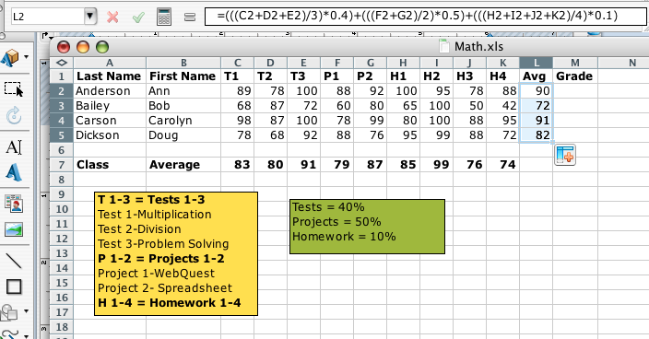

If the formula is entered correctly, I will see the average grade appear when I click return.
Click on the lower right hand corner of the cell with the average grade in it and drag down to the last row containing grades (L2-L5). the spreadsheet will fill in the average grades for the rest of the students.

Formatting data
Averages can be displayed to whatever precision you wish to use. you can use one decimal place, or you may wish to use zero decimal places. Zero decimal places would keep the grades in a format like they are reported to students. An advantage of using zero decimal places would be to avoid confusion regarding rounding grades. To illustrate this consider the following grade:
- A grade of 75.49 would round to 75 with zero decimal places. However, at one decimal place that grade rounds to 75.5 and students would have the expectation that the grade would round to 76. Using zero decimal places will allow Excel to round without confusion to some students.

How to format
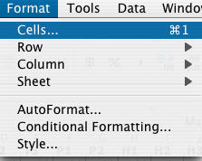
1. Highlight the column to be formatted by clicking on the letter at the top of the column (in this case L). From the Format menu choose Cells
From the Format Cells window choose Number and then select the number of decimal places you want to use.

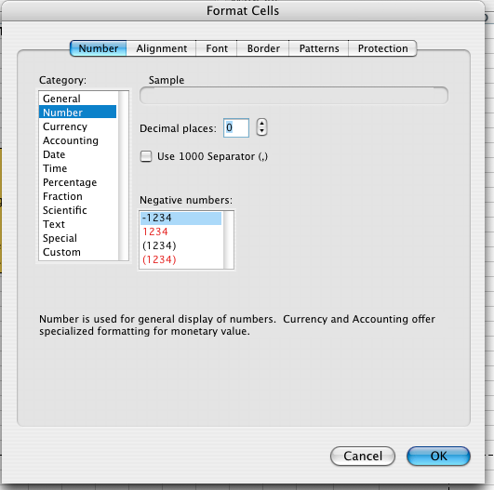

Using a Lookup table
Now we will ask Excel to look at the numerical average in column L and compare it to a list which defines the grading scale, for the purpose of assigning a letter grade to the average.
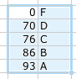
The information to the left, defining the grade scale must be entered in ascending order from top to bottom. The number entered to the left of a letter must be the lowest number grade that would equal that letter grade.
- Enter the numbers and letters
- Highlight the entire range from the cell with the score 0 to the cell with the grade A.
- Go to the Insert menu, select Name and choose Define
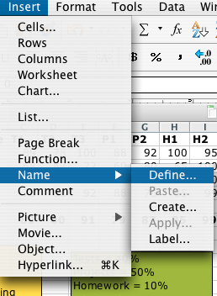

Give a name to this lookup table, I called mine grades. Next we will write an equation which will look at a student's numerical average, look at a list of grades, and assign a letter grade to the student. This is done with a functioned named VLOOKUP. The equation must specify three elements:
- The location of the numerical grade to be compared (L2 in the example)
- The name of the lookup table (grades)
- The location of the letter grade in the lookup table (2) [because the letter grade is in column 2 in the lookup table]
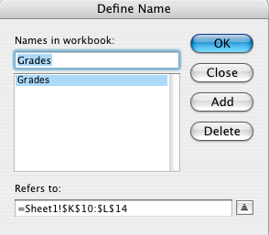

Enter the following equation in the formula bar:

=VLOOKUP(L2,Grades,2)

After the equation is entered in the formula bar, click return and the appropriate grade will appear in Cell M2. Click and drag to fill the equation down into the remainder of the grade book.

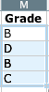
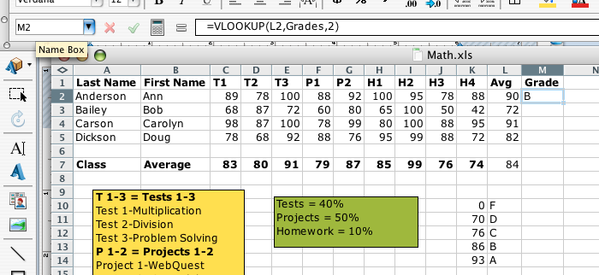

Congratulations! Good job!

For the project, your task is to replicate this grade book using your own students (minimum of 20) and your own assignments. The assignments in the legend should be ones that would directly assess the objectives you selected.

